
ONE TO ONE MENTORING REQUEST FORM
“We mentor young people to reduce distress, build resilience & achieve more”

TELL US ABOUT THE YOUNG PERSON

Name: |  |  | School:
Gender: |  | Date of birth: |  | School Year:
 |  |  |  | Current attendance %:
Young Person school email address:

REASON FOR REQUESTING ONE-TO-ONE MENTORING

Reasons for mentoring? Please include as much relevant information about the young person:

In what ways will mentoring address the issues? Please mention specific intended outcomes:

CHECKLIST (Please delete as appropriate)
Lifespace Mentoring sessions will be : | Face to Face / Phone / MS Teams / Any of these

PERMISSION: | Has mentoring by face to face / telephone / MS Teams been explained to the young person? | Yes / No
 | Has consent been gained from a parent/carer for the above? | Yes / No
 | Has the young person agreed to mentoring? | Yes / No
SEN: | Does this young person have Special Educational Needs? | Yes / No / Unsure
RISE: | Have they been referred to RISE? | Yes / No / Unsure
PP: | Are they accessing Pupil Premium? | Yes / No / Unsure
CLA: | Are they Care Experienced? | Yes / No / Unsure
EARLY HELP: | Has there been an Early Help Assessment for the family | Yes / No / Unsure

NB. You MUST complete Risk Assessment over the page
RISK ASSESSMENT

TELL US ABOUT CURRENT RISKS observed or known about recently:

Harm to others (include reckless or manipulative behaviour):
Harm to self (include use of alcohol/drugs):
Harm from others*:
Events of loss*:
Thoughts of suicide*
Are you aware of a history of Adverse Childhood Experiences Y/N
If yes , please give as much information as possible.

*Please note - we are willing to work alongside other professionals where:
1. The young person has already attempted suicide - contact should also be made with RISE / GP
2. There is a recent or expected family bereavement – contact should also be made with ECHOES service
3. The young person is witness to domestic abuse / experienced physical abuse – also contact a specialist service

Does anything specific need to be considered to manage the risks with this request? Yes / No

Who to keep informed / other comments:

Signed by person authorising request: Date:

Your relation to young person (circle): Teacher / Parent / Carer / Other (specify):

Your email: Phone no.

---------------------------------------------------------------------------------------------------------------------------------

WHO TO INVOICE FOR THE MENTORING (Please delete as appropriate)

Who is paying for the mentoring? School / Parent / Other (specify):

Contact details for the invoice if not School:
(Please include postal address, email address and phone number)

THIS INFORMATION IS STRICTLY CONFIDENTIAL AND IS ONLY FOR ATTENTION OF LIFESPACE TRUST. IT IS NOT TO BE SHARED & MUST BE STORED SECURELY

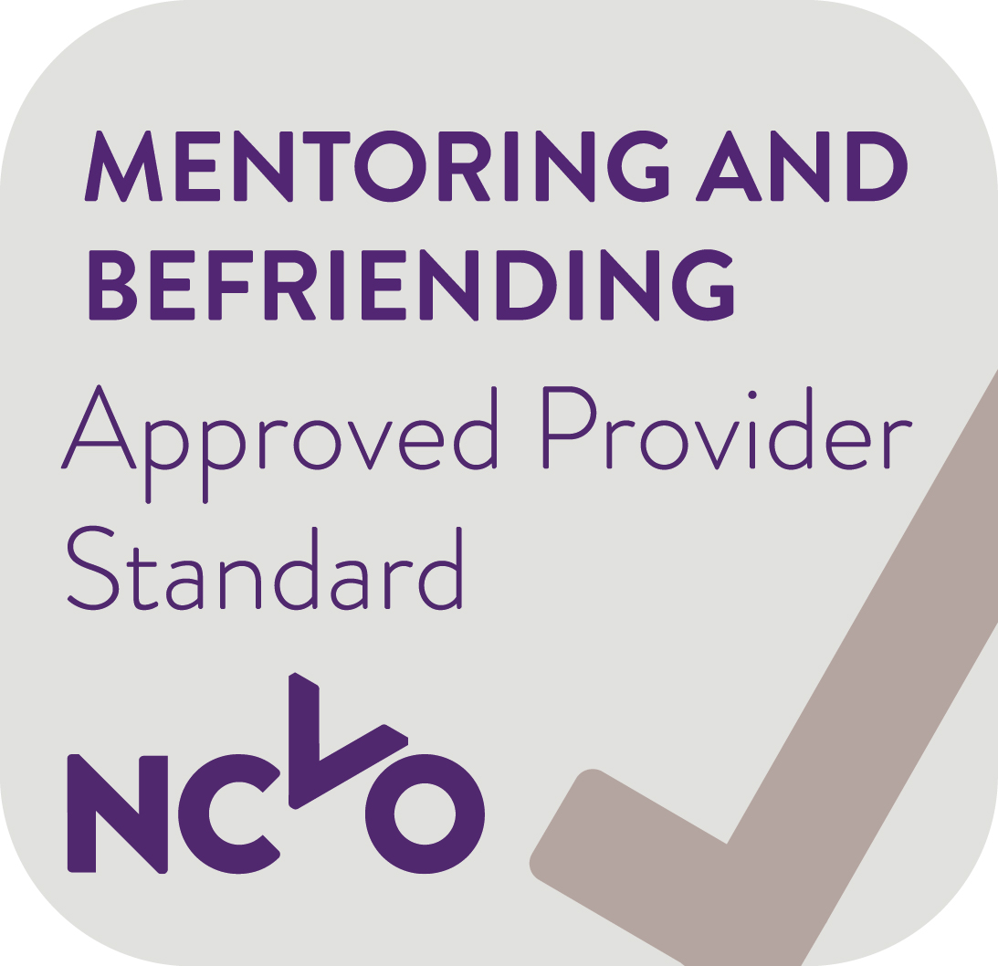
Lifespace Trust, Tyler House, Tyler St, Stratford-Upon-Avon, Warks. CV37 6TY
Tel: 01789 297400 Email: admin@lifespace.org.uk Web: www.lifespace.org.uk

Lifespace Trust is an Approved Provider & has been awarded The Queen’s Award for Voluntary Service

